Dr Raju Nadimpalli

STATISTICS

Statistics is the study of how to collect, organize, analyze, and interpret numerical information from data.

population the total set of individuals that we are interested about and a sample a subset of the individuals selected in a prescribed manner of study.

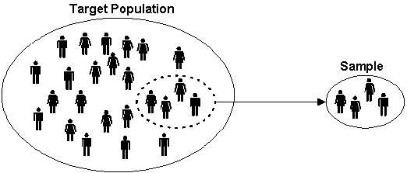

- Observation: Result from one trial of an experiment.
- Sample: Group of results gathered from separate independent trials.
- Population: Space of all possible observations that could be seen from a trial.

We can classify data into two types:
- Numerical or Quantitative data is data where the observations are numbers. For example, age, height, on a scale from one to ten..., distance, number of,...
- Categorical or Qualitative data is data where the observations are non-numerical. For example, favorite color, choice of politician, ...
Data is called univariate if it represents one attribute and bivariate if it contains two attributes.
Bivariate data is often used to compare.
Numerical data is called discrete if the number of possible values within every bounded range is finite. Examples include rolling dice, number of times that..., ...
Otherwise, numerical data is called continuous. For example, height, weight, temperature, distance, ...
Data Analysis
With data analysis, two main statistical methods- Descriptive and Inferential.
- Descriptive statistics uses tools like mean and standard deviation on a sample to summarize data.
- Inferential statistics, on the other hand, looks at data that can randomly vary, and then draw conclusions from it.

Measure of central tendency is a value that represents a typical, or central, entry of a data set.

The sample mean is the average and is computed as the sum of all the observed outcomes from the sample divided by the total number of events.
We use x as the symbol for the sample mean. In math terms,
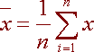
where n is the sample size and the x correspond to the observed valued.
34, 43, 81, 106, 106 and 115
We compute the sample mean by adding and dividing by the number of samples, 6.
34 + 43 + 81 + 106 + 106 + 115
= 80.83
6
The mode of a set of data is the number with the highest frequency.
In the above example 106 is the mode, since it occurs twice, and the rest of the outcomes occur only once.

The mean will be strongly affected by this outcome. Such an outcome is called and outlier.

An alternative measure is the median. The median is the middle score.

The value that lies in the middle of the data when the data set is ordered.

If the data set has an odd number of entries, then the median is the middle data entry.

If the data has an even number of entries, then the median is obtained by adding the two numbers in the middle and dividing result by two.

Outliers are not just greatest and least values, but values that are very different from the pattern established by the rest of the data. Outliers affect the mean.

When outliers are present it is best to use the median as the measure of central tendency.

If we have an even number of events, we take the average of the two middles.
2.7, 2.9, 3.1, 3.4, 3.7, 4.1, 4.3, 4.7, 4.7, 40.8
Since there is an even number of outcomes, we take the average of the middle two
3.7 + 4.1
= 3.9
2
Example: -
44, 50, 38, 96, 42, 47, 40, 39, 46, 50.
To find the sample mean, add them and divide by 10:
44 + 50 + 38 + 96 + 42 + 47 + 40 + 39 + 46 + 50
= 49.2
10
To find the median, first sort the data:
38, 39, 40, 42, 44, 46, 47, 50, 50, 96
Notice that there are two middle numbers 44 and 46.
To find the median we take the average of the two.
44 + 46
Median = = 45
2
Notice also that the mean is larger than all but three of the data points.
The mean is influenced by outliers while the median is robust.

The mean, mode, median, and trimmed mean do a nice job in telling where the center of the data set is,

Measures of Variation:

• Range: The difference between the maximum and minimum data entries in the set.

Range = (Max. data entry) – (Min. data entry)

The standard deviation measure variability and consistency of the sample or population.
In most real-world applications, consistency is a great advantage.
In statistical data analysis, less variation is often better.

We define the variance to be
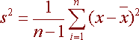
and the standard deviation to be
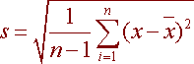
Variance and Standard Deviation: Step by Step
- Calculate the mean, x.
- Write a table that subtracts the mean from each observed value.
- Square each of the differences.
- Add this column.
- Divide by n -1 where n is the number of items in the sample This is the variance.
- To get the standard deviation we take the square root of the variance.
Example
following data.
44, 50, 38, 96, 42, 47, 40, 39, 46, 50
He calculated the mean by adding and dividing by 10 to get
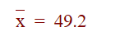
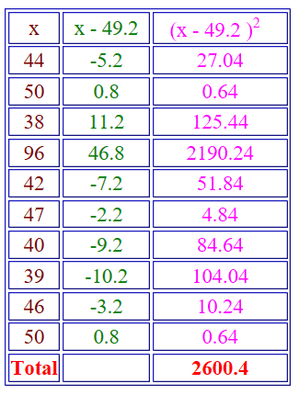
Now
2600.4
= 288.7
10 - 1
Hence the variance is 289 and the standard deviation is the square root of 289 = 17.
Since the standard deviation can be thought of measuring how far the data values lie from the mean,

we take the mean and move one standard deviation in either direction.

The mean for this example was about 49.2 and the standard deviation was 17. We have:
49.2 - 17 = 32.2
and

49.2 + 17 = 66.2

What this means is that most of the patrons probably spend between $32.20 and $66.20.
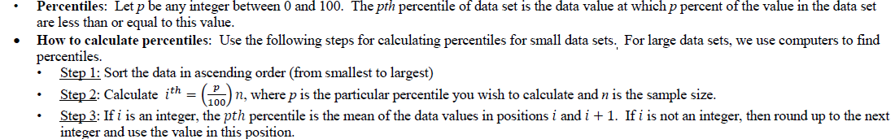
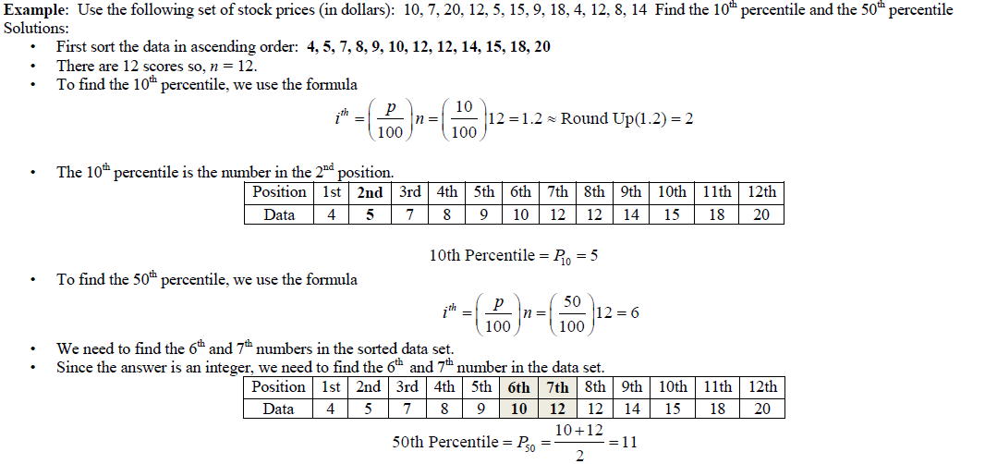

The frequency of a event is the number of times that the event occurs.
The relative frequency is the proportion of observed responses in the category.
The relative frequency is computed by dividing the frequency by the total number of respondents.
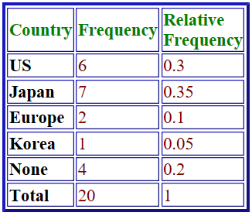
Bar Chart
- A bar chart is a graphical representation of categorical data or discrete data using rectangular bars.
- Axes:
  - X-axis (horizontal axis) → represents the categories (qualitative variables like fruits, grades, cities).
  - Y-axis (vertical axis) → represents the frequency, relative frequency, or percentage.
- Bars:
  - Each category is represented by a bar.
  - The height (or length) of the bar is proportional to the value it represents.
  - Bars are of equal width and are separated by equal gaps (to distinguish categories).
- Data type:
Used for categorical data (nominal/ordinal) or discrete numerical data.
- Interpretation:
  - Taller bar = higher frequency/percentage.
  - Shorter bar = lower frequency/percentage.
  - Makes comparison across categories easy.
- Types:
  - Simple bar chart → shows one variable.
  - Multiple bar chart → compares two or more related variables.
  - Stacked bar chart → shows sub-division within categories.

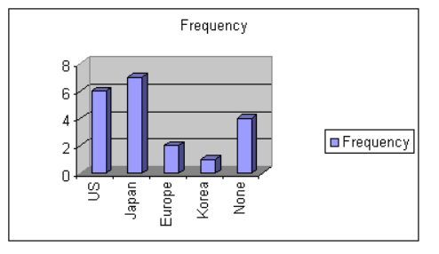
Histogram
- A histogram is a graphical representation of continuous numerical data. It shows the frequency distribution of a dataset by dividing the entire range of values into intervals (called bins or class intervals).
- Axes
  - X-axis (horizontal axis) → class intervals (ranges of data values).
  - Y-axis (vertical axis) → frequency (or relative frequency, or density).
- Bars
  - Bars represent intervals (not categories).
  - Bars are adjacent (touching each other) because data is continuous.
  - The area of the bar (not just height) is proportional to frequency.
- Data type
Used for quantitative, continuous data (like heights, weights, marks, income, age, etc.).
- Interpretation
  - Shape of histogram shows distribution of data (e.g., symmetric, skewed, uniform).
  - Helps to see patterns like central tendency, spread, outliers.
Example:
The depth of clarity of Lake Tahoe was measured at several different places with the results in inches as follows:
15.4, 16.7, 16.9, 17.0, 20.2, 25.3, 28.8, 29.1, 30.4, 34.5, 36.7, 39.1, 39.4, 39.6, 39.8, 40.1, 42.3, 43.5, 45.6, 45.9, 48.3, 48.5, 48.7, 49.0, 49.1, 49.3, 49.5, 50.1, 50.2, 52.3
We use a frequency distribution table with class intervals of length 5.
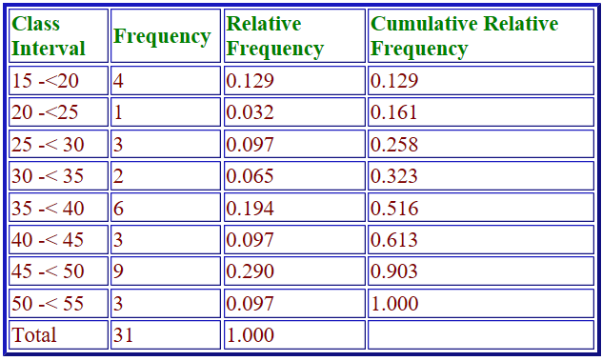
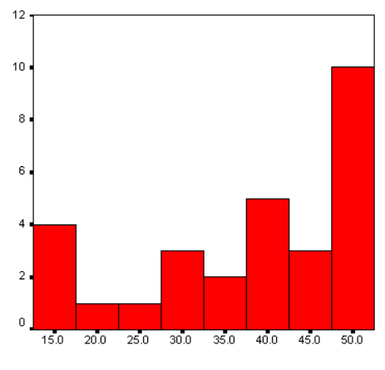
The Shape of a Histogram
A histogram is unimodal if there is one hump, bimodal if there are two humps and multimodal if there are many humps.
A nonsymmetric histogram is called skewed if it is not symmetric.
If the upper tail is longer than the lower tail then it is positively skewed.
If the upper tail is shorter than it is negatively skewed.

Feature | Histogram | Bar Chart
Data type | Continuous (quantitative) | Categorical (qualitative/discrete)
X-axis | Intervals (bins) | Categories
Bars touching? | Yes (no gaps) | No (gaps between bars)
Represents | Frequency distribution | Category comparison
Focus | Shape & spread of data | Comparison across groups

There are special percentile that deserve recognition.
- The second quartile (Q₂) is the median or the 50th percentile
- The first quartile (Q₁) is the median of the data that falls below the median. This is the 25th percentile
- The third quartile (Q₃) is the median of the data falling above the median. This is the 75th percentile
We define the interquartile range as the difference between the first and the third quartile
IQR = Q₃ - Q₁
Boxplot
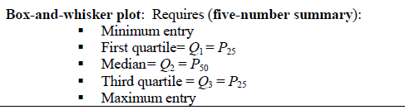
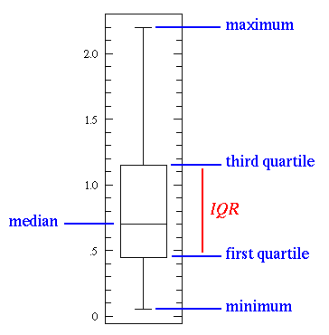

Central Limit Theorem
The Central Limit Theorem, or CLT for short, is an important finding and pillar in the fields of statistics and probability.
The theorem states that as the size of the sample increases, the distribution of the mean across multiple samples will approximate a Gaussian distribution.
If we calculate the mean of a sample, it will be an estimate of the mean of the population distribution. But, like any estimate, it will be wrong and will contain some error. If we draw multiple independent samples, and calculate their means, the distribution of those means will form a Gaussian distribution.
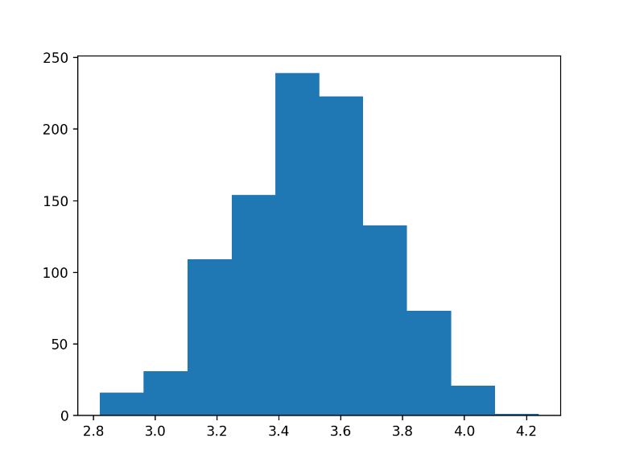

A normal distribution, sometimes called the bell curve, is a distribution that occurs naturally in many situations.
The empirical rule tells you what percentage of your data falls within a certain number of standard deviations from the mean:
• 68% of the data falls within one standard deviation of the mean.
• 95% of the data falls within two standard deviations of the mean.
• 99.7% of the data falls within three standard deviations of the mean.
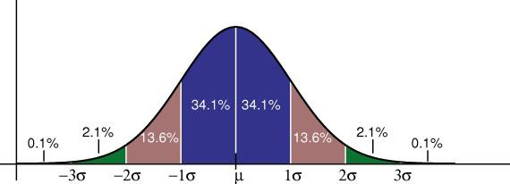
The Normal Distribution has:
- mean = median = mode
- symmetry about the center
- 50% of values less than the mean
and 50% greater than the mean

Z Score Formula:

The basic z score formula for a sample is:
z = (x – μ) / σ
For example, let’s say you have a test score of 190. The test has a mean (μ) of 150 and a standard deviation (σ) of 25.

Assuming a normal distribution, your z score would be:
z = (x – μ) / σ
= 190 – 150 / 25 = 1.6.
The z score tells you how many standard deviations from the mean your score is. In this example, your score is 1.6 standard deviations above the mean.
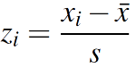
Problem Statement:
A survey of daily travel time had these results (in minutes):
26 | 33 | 65 | 28 | 34 | 55 | 25 | 44 | 50 | 36 | 26 | 37 | 43 | 62 | 35 | 38 | 45 | 32 | 28 | 34
The Mean is 38.8 minutes, and the Standard Deviation is 11.4 minutes. Convert the values to z - scores and prepare the Normal Distribution Graph.
Solution:

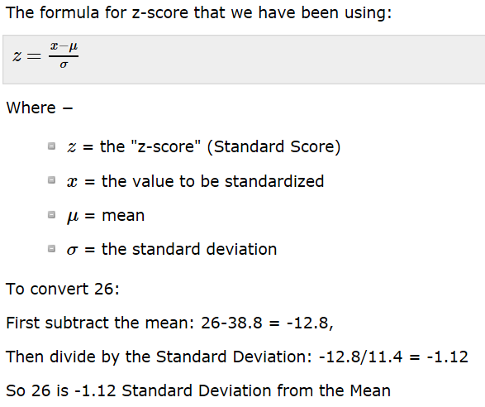
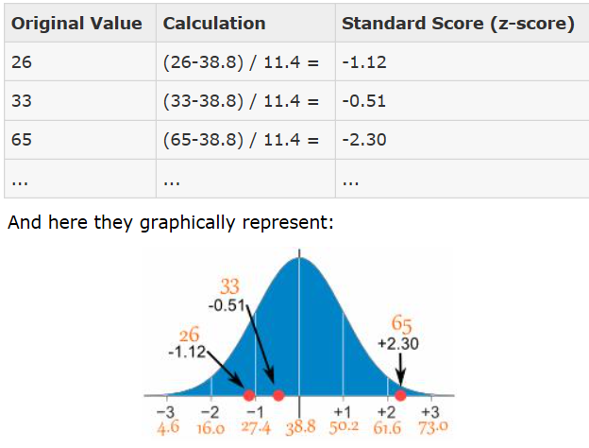
Skewness
Skewness is a measurement of the symmetry of a distribution.
Therefore, it describes how much a distribution differs from a normal distribution, either to the left or to the right. The skewness value can be either positive, negative or zero.
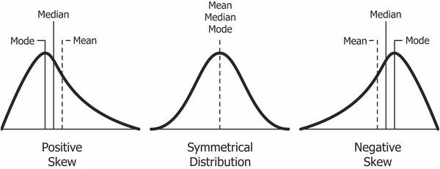

A Positives skew if the data is piled up to the left, which leaves the tail pointing to the right.
A negative skew occurs if the data is piled up to the right, which leaves the tail pointing to the left.
Note that positive skews are more frequent than negative ones.

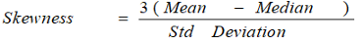
If the skewness is zero, the distribution is symmetrical.
If it is negative, the distribution is Negatively Skewed and
if it is positive, it is Positively Skewed.

Kurtosis
Kurtosis measures whether your dataset is heavy-tailed or light-tailed compared to a normal distribution.
Data sets with high kurtosis have heavy tails and more outliers and
data sets with low kurtosis tend to have light tails and fewer outliers.

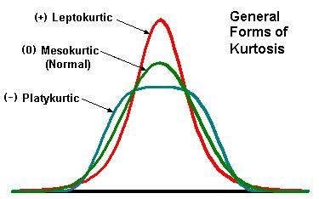
There are three types of Kurtosis

Mesokurtic
Mesokurtic is the distribution which has similar kurtosis as normal distribution kurtosis, which is zero.
Leptokurtic
Distribution is the distribution which has kurtosis greater than a Mesokurtic distribution. Tails of such distributions are thick and heavy. If the curve of a distribution is more peaked than Mesokurtic curve, it is referred to as a Leptokurtic curve.
Platykurtic
Distribution is the distribution which has kurtosis lesser than a Mesokurtic distribution. Tails of such distributions thinner. If a curve of a distribution is less peaked than a Mesokurtic curve, it is referred to as a Platykurtic curve.
The main difference between skewness and kurtosis is that the skewness refers to the degree of symmetry, whereas the kurtosis refers to the degree of presence of outliers in the distribution.

Sampling methods
In a statistical study, sampling methods refer to how we select members from the population to be in the study.
If a sample isn't randomly selected, it will probably be biased in some way and the data may not be representative of the population.

Simple random sample: Every member and set of members has an equal chance of being included in the sample.
Technology, random number generators, or some other sort of chance process is needed to get a simple random sample.
Random samples are usually representative since they don't favor certain members.
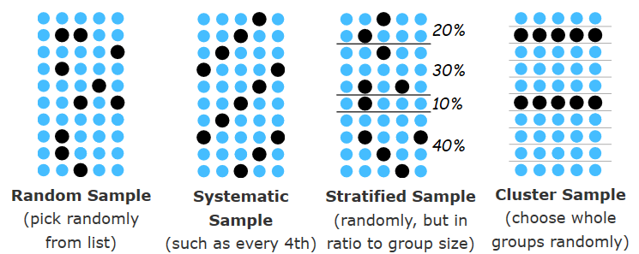
Stratified random sample: The population is first split into groups.
The overall sample consists of some members from every group. The members from each group are chosen randomly.
A stratified sample guarantees that members from each group will be represented in the sample, so this sampling method is good when we want some members from every group.
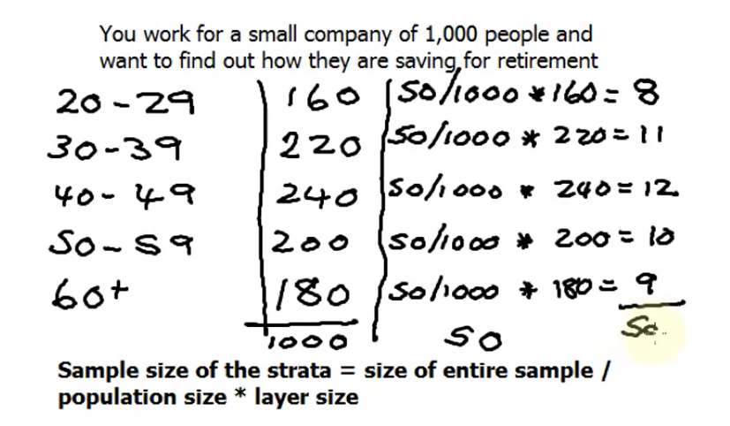
Cluster random sample: The population is first split into groups. The overall sample consists of every member from some of the groups. The groups are selected at random.
A cluster sample gets every member from some of the groups, so it's good when each group reflects the population.
Systematic random sample: Members of the population are put in some order. A starting point is selected at random, and every n^{th}, member is selected to be in the sample.

Chi-Square Test
This is the formula for Chi-Square:
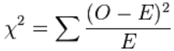
- O = the Observed (actual) value
- E = the Expected value
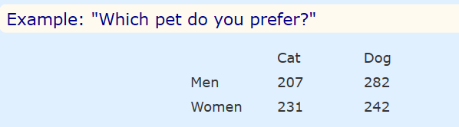
This test only works for categorical data (data in categories), such as Gender {Men, Women} or color {Red, Yellow, Green, Blue} etc, but not numerical data such as height or weight.

Hypothesis: A statement that might be true, which can then be tested.
The two hypotheses are.
- Gender and preference for cats or dogs are independent.
- Gender and preference for cats or dogs are not independent.

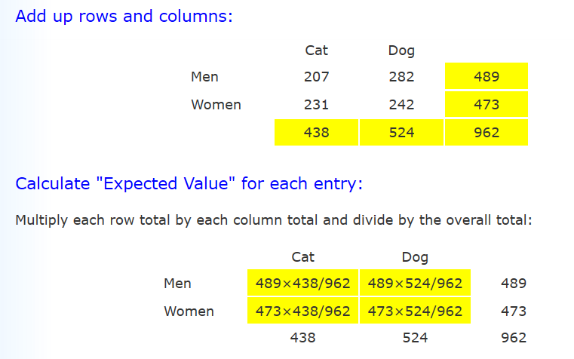
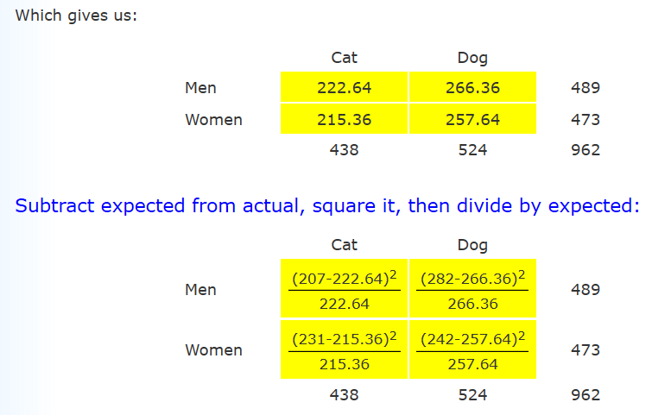
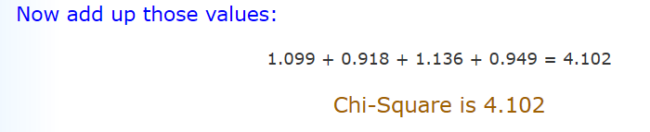

Calculate Degrees of Freedom
Multiply (rows − 1) by (columns − 1)
Example: DF = (2 − 1)(2 − 1) = 1×1 = 1

Result
The result is:
p = 0.04283
In this case p < 0.05, so this result is thought of as being "significant" meaning is that the variables are not independent.
In other words, because 0.043 < 0.05 so Gender is linked to Pet Preference (Men and Women have different preferences for Cats and Dogs).
